



Flarem Plus Sdn Bhd

**Software User Manual**

# 1.0 Installation Guide

Go to Browser Open the link in the user's device.

# User Manual

* 1. **Moderator Manual Instructions**
     1. **User Signup**

**STEP 1**: Click the ‘Sign Up’ button in the on top right of the main page.

**STEP 2**: Fill up the required details.

**STEP 3**: Click the ‘Sign Up’ button.



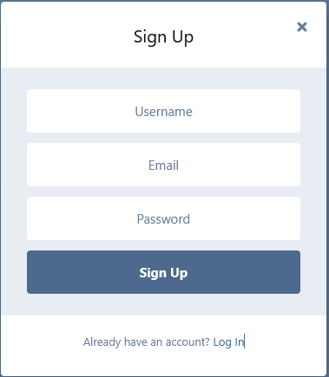

User has registered successfully and instantly log in and confirmation will pop out indicating the account is created



Go to the registered email account to activate the account by clicking the link

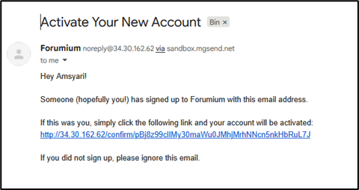

An error message will pop out if an existing email is used or there is an empty field.

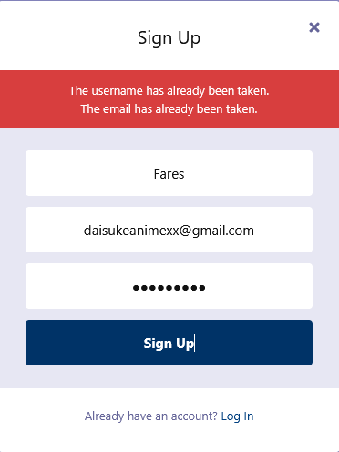

# User, Moderator and Administrator Login

**STEP 1**: Click the ‘Log in’ button on the top right of the Main Page.

**STEP 2**: Fill up the required fields.

**STEP 3**: Click the ‘Log In’ button.

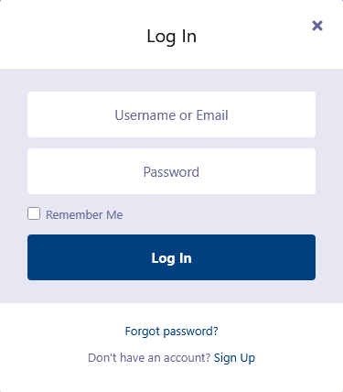

An error message will pop out if an invalid input is entered or there is an empty field.

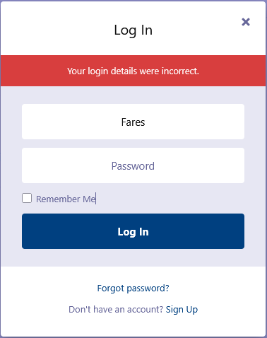

# Forgot Password

**STEP 1**: Click the ‘Forgot Password’ button in the Login Page to reset password.

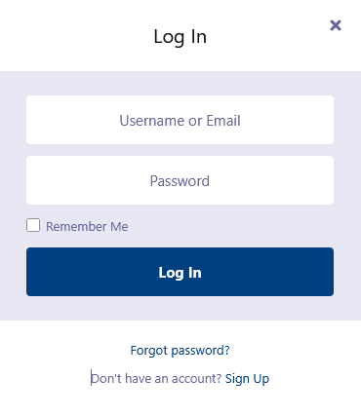

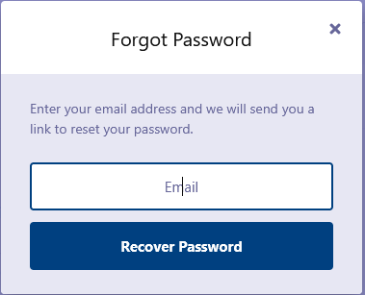

**STEP 2**: Enter your email account and click “Recover Password” and reset link will be set to the email

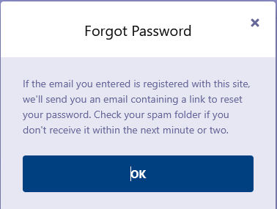

Click OK Button to confirm or close to exit the window.

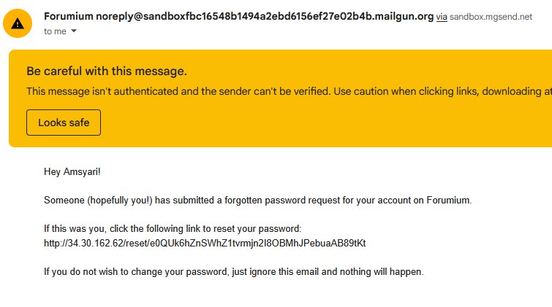

**STEP 3**: Click or copy paste the link to reset your password.

**STEP 4**: Enter your new password in the provided box and click the ‘Save Changes’ button.

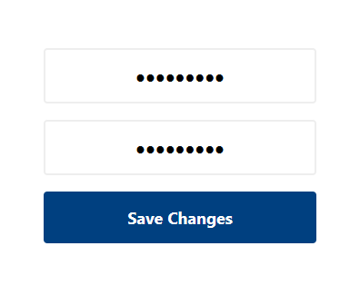

After the changes, you will automatically log in can now sign in with your new password in the future

# View Profile

Click the ‘Profile’ button in the Main Page to see their past posts and discussion.

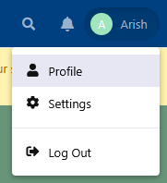

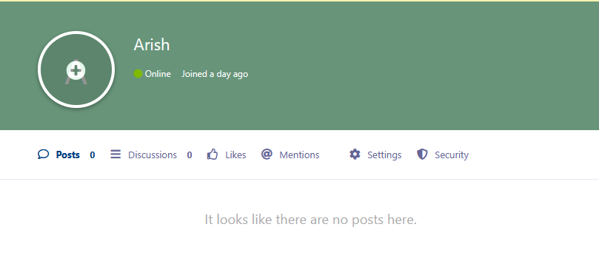

User can change setting on their account like password, email, notifications and privacy

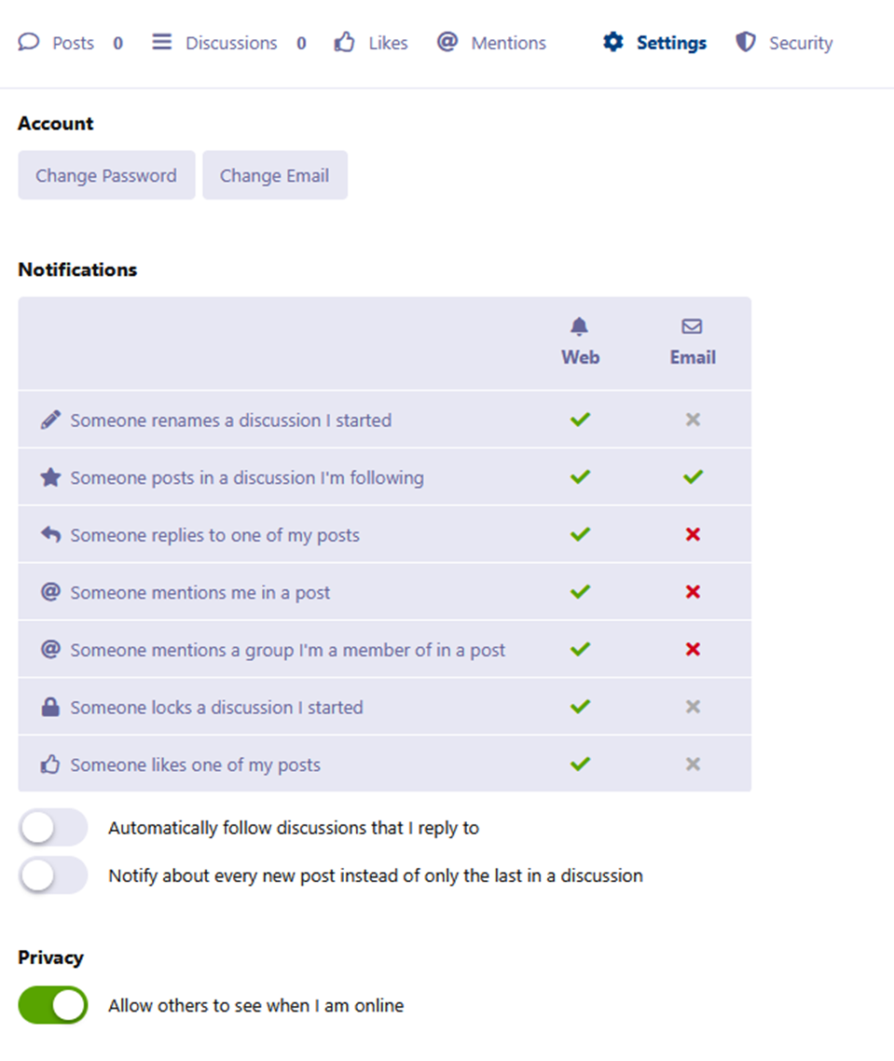

User able to terminate sessions and global log out via security tab

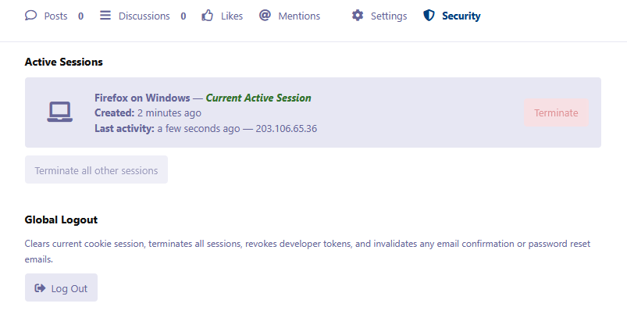

# Post Discussion

Click the ‘Start a Discussion’ button in the Main Page. The member can check the latest news / events / announcements made by the faculty.

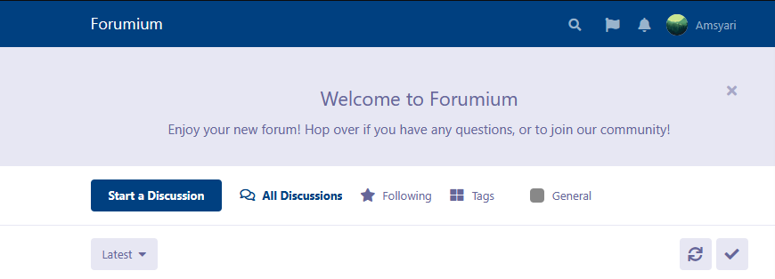

Write a discussion title and post. Options for uploading image, emoji, and text formatting is available.

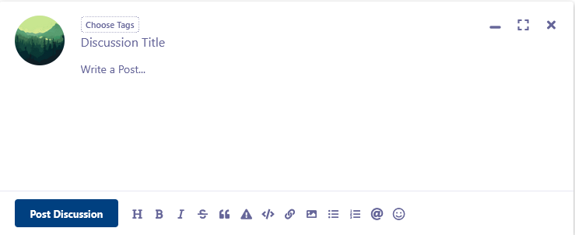

* 1. **Admin Manual Instructions**

Click on your profile on top right to access Administration for admins by clicking the button.

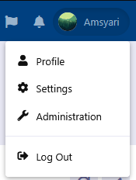

# View User Profile

Click the ‘Users’ button in the Admin Main Page. The admin can see the user's details.

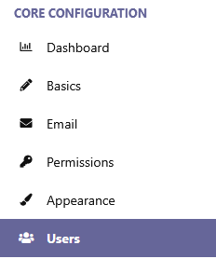

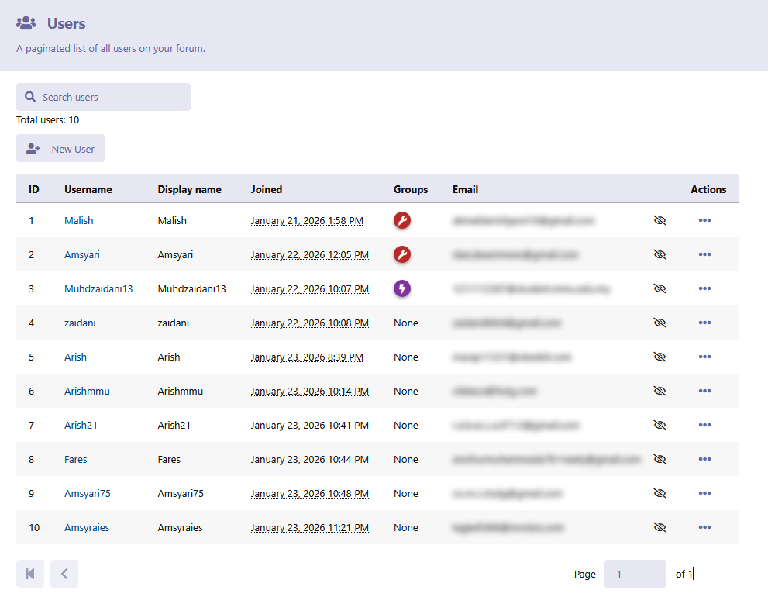

# Check Dashboard

**STEP 1**: Click the ‘Dashboard’ button in the Admin Main Page.

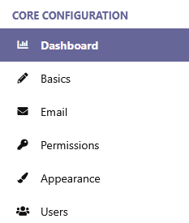

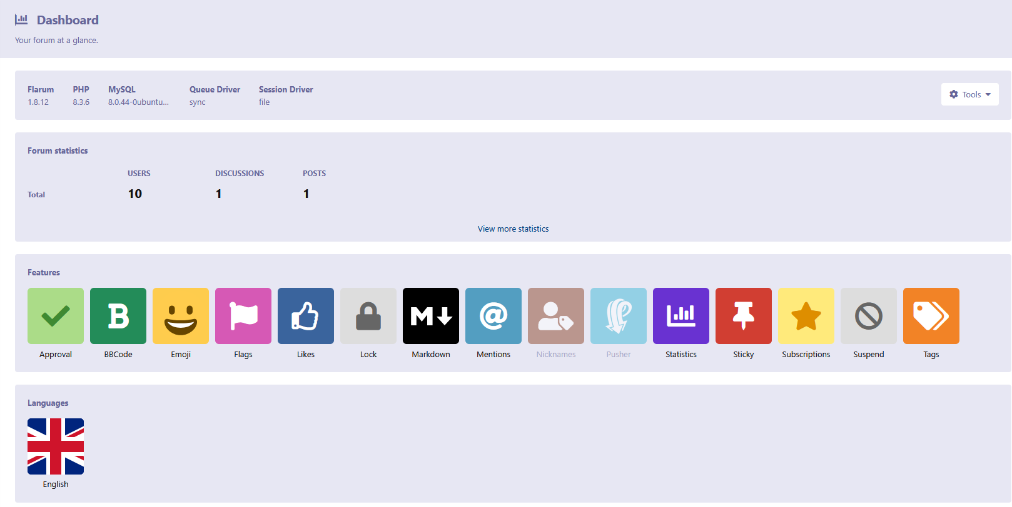

**Configure Basics**

Click Basics button to set forum title, description and other settings.

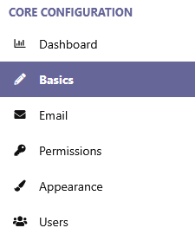

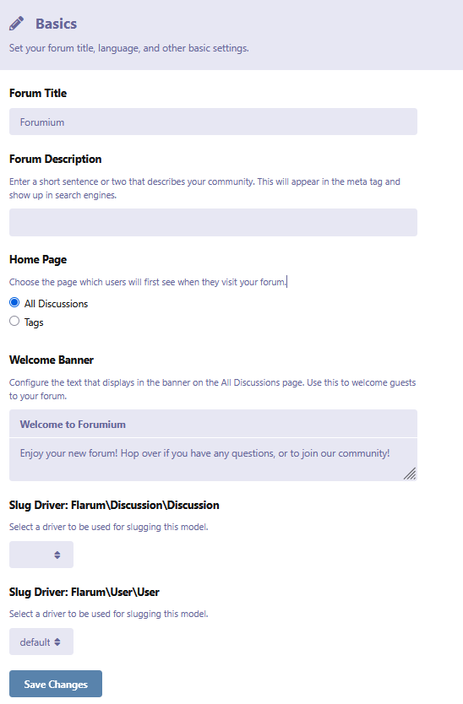

**View and Edit Permission**

Click ‘Permission’ button to configure role, who can see and do.

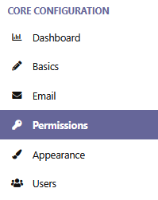

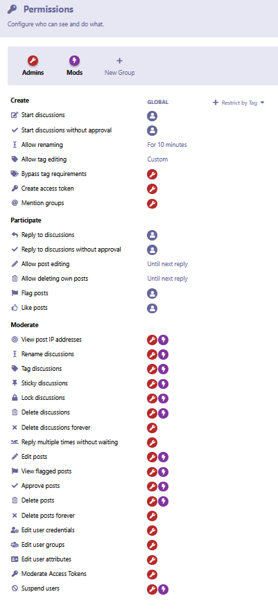

**Configure Appearance**

Adjust whole page theme style, colours, logo, custom header and footer.

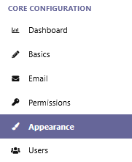

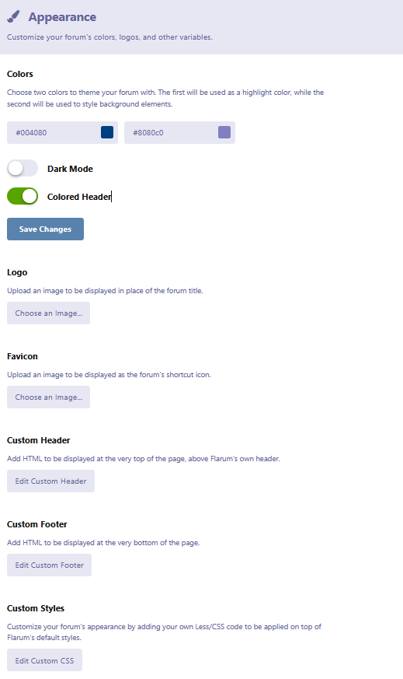

**Sign Up Register User Backend PHP**

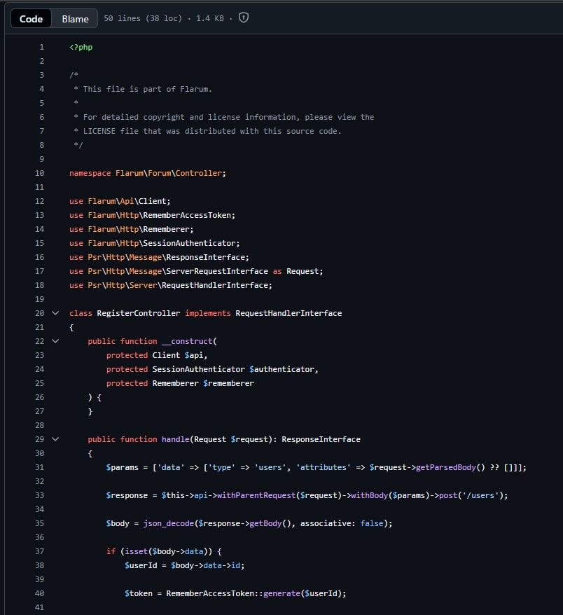

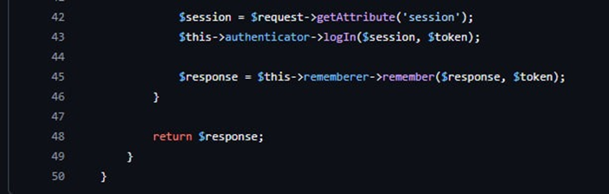

**Sign Up Register User Frontend**

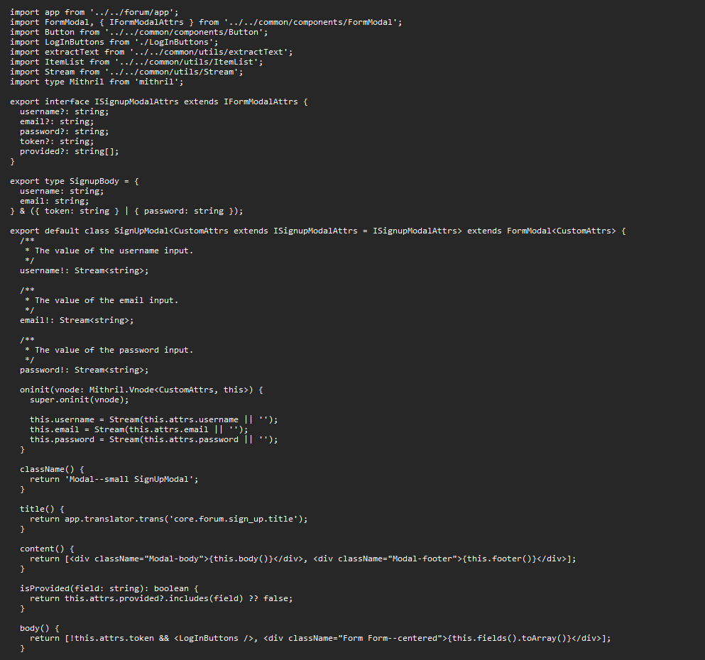

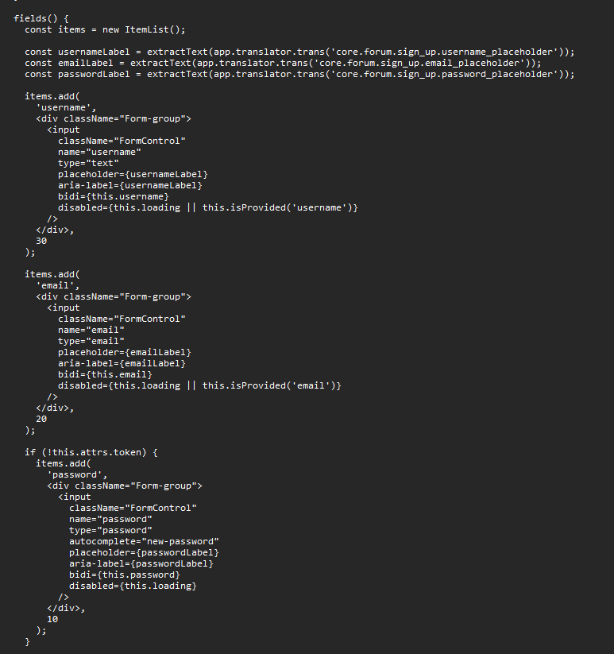

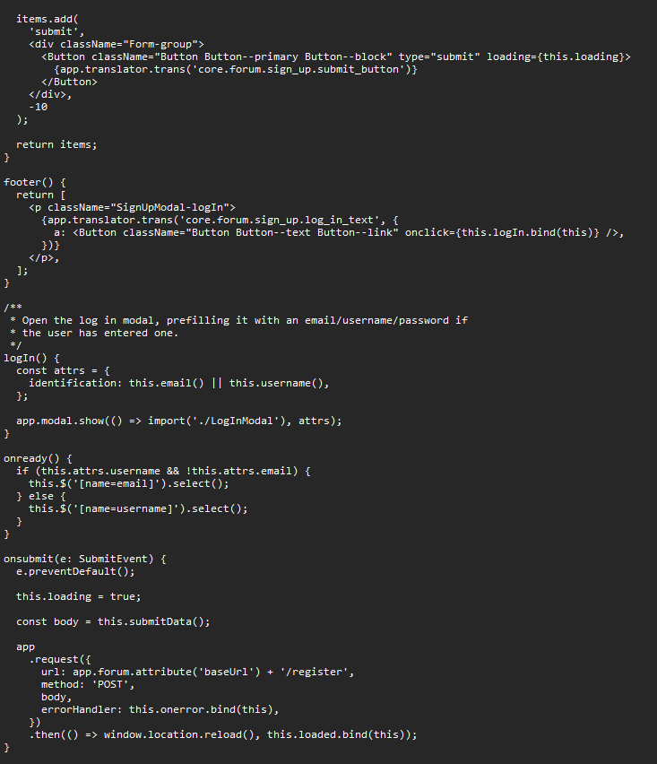

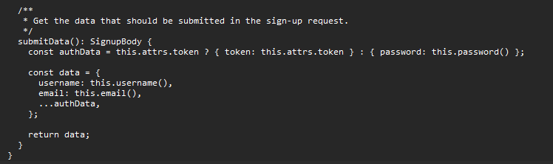

**Log in Backend PHP**

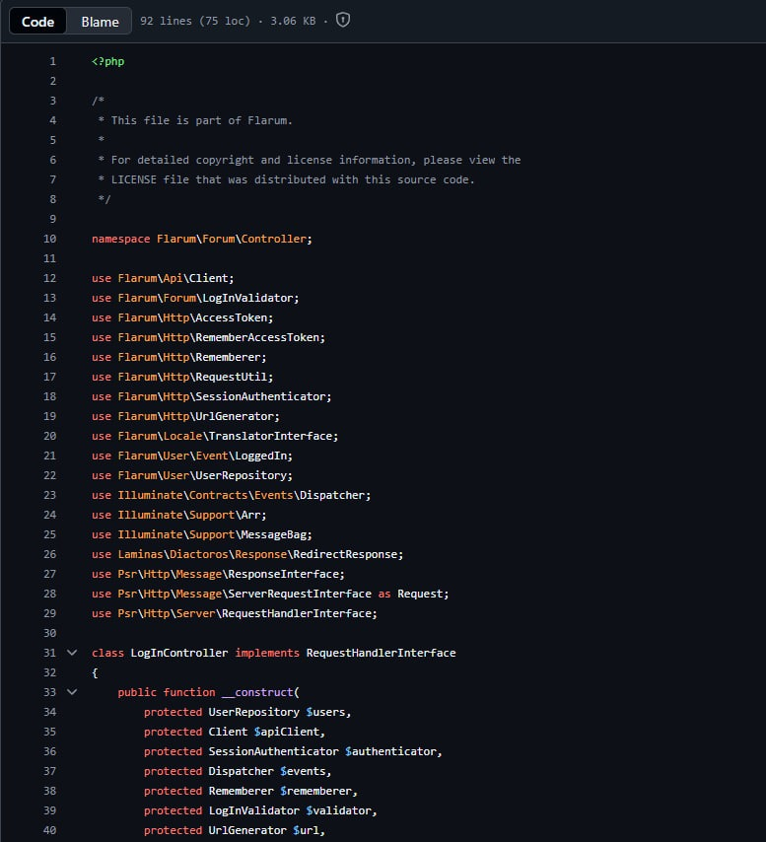

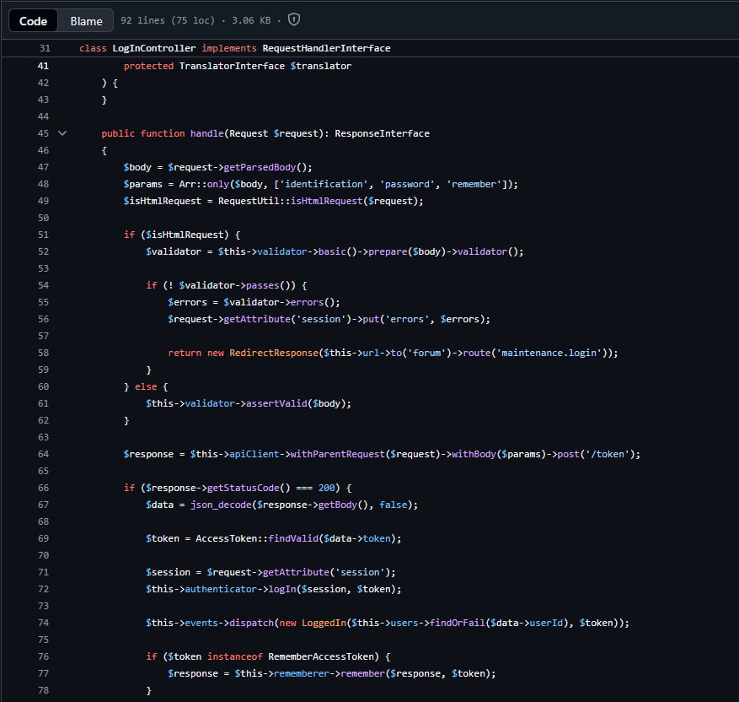

**Log in User, Moderator & Admin Frontend**

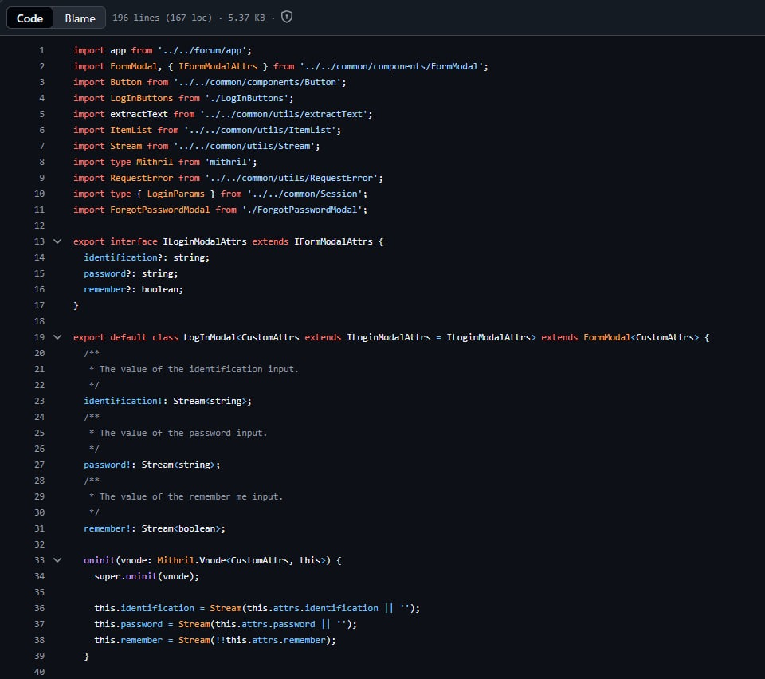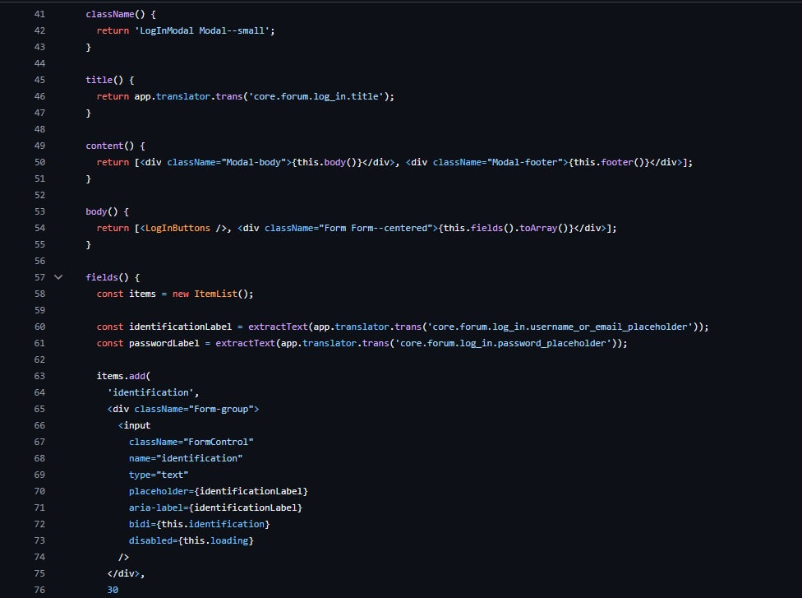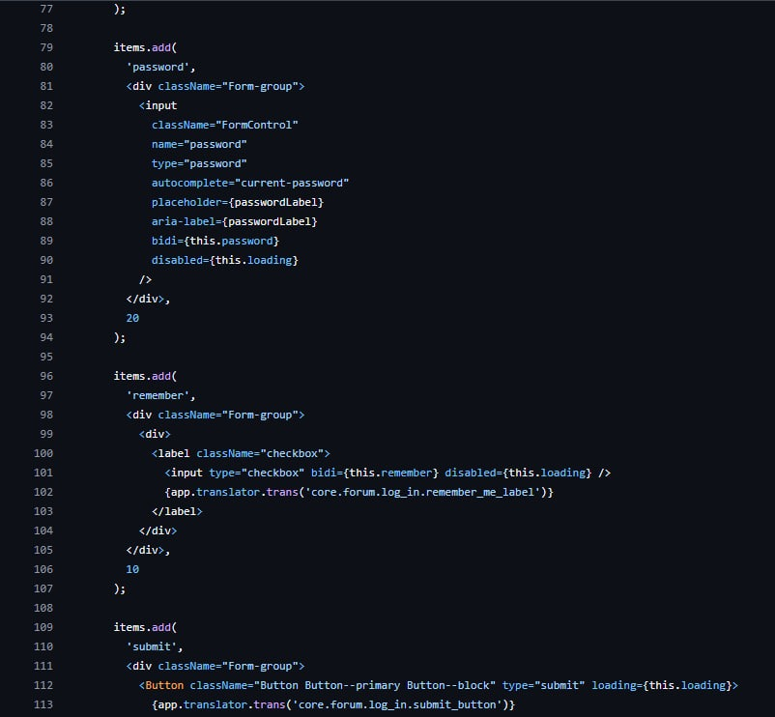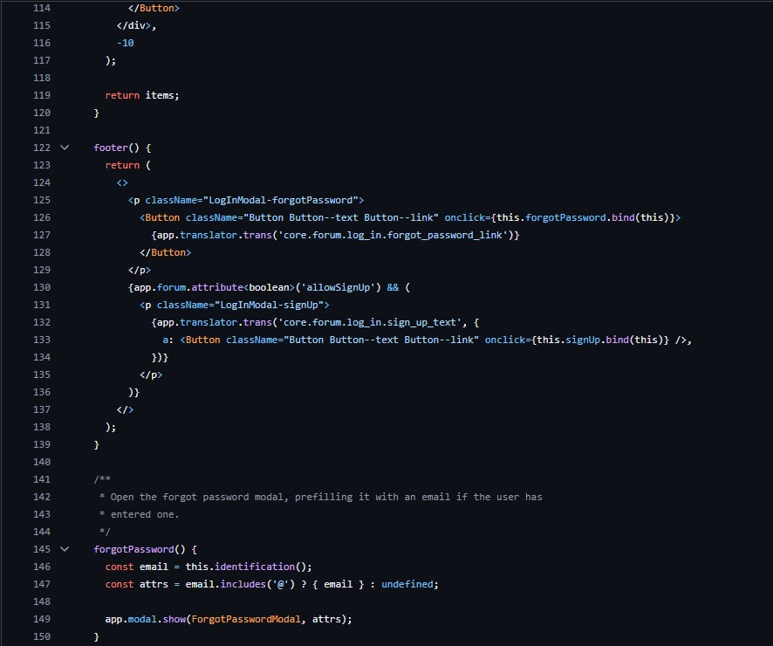

**Post Discussion Frontend**

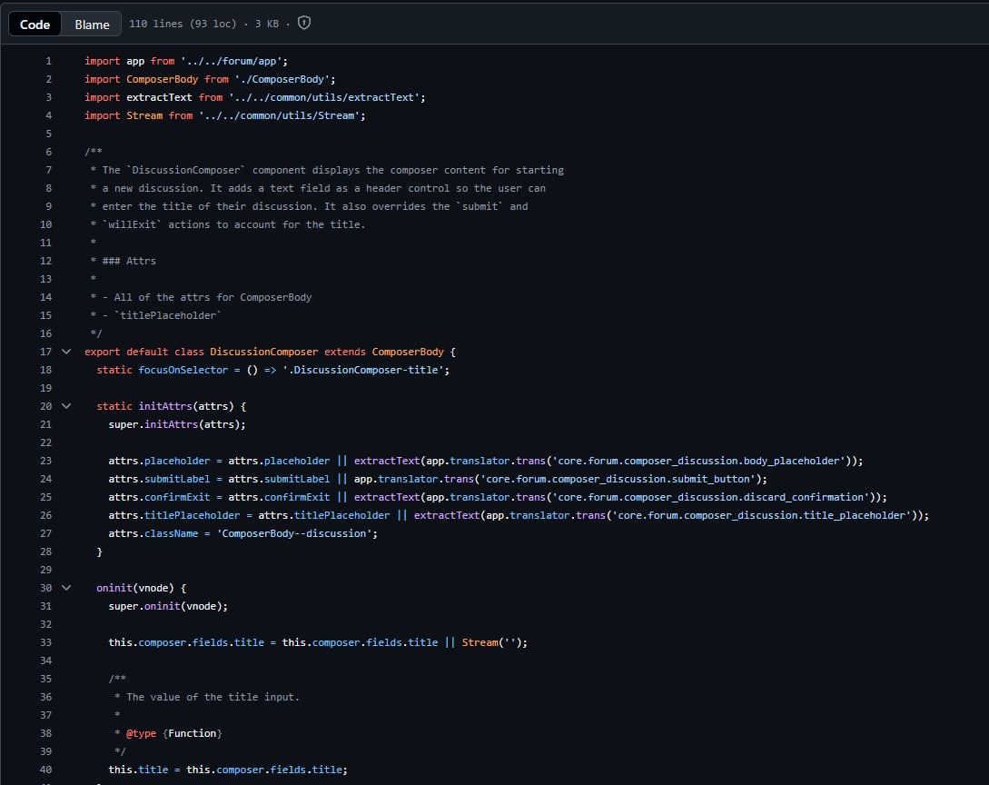

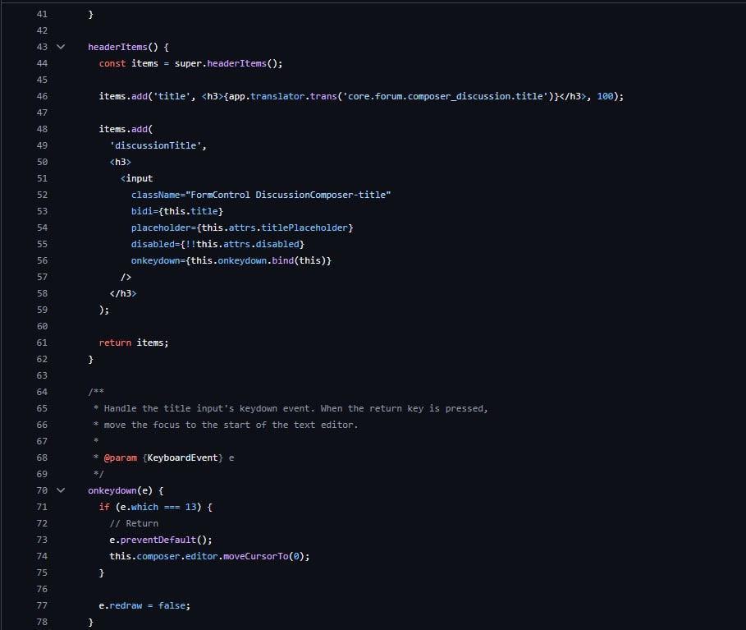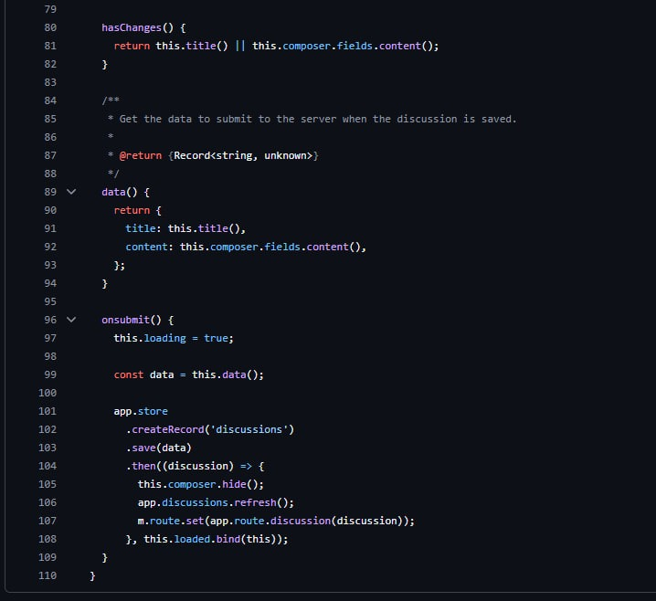

**Project Post-mortem Report**

**Project Title:** Forumium: A Web Based Forum Platform for Students

**Team Members:**

1. Faris Amsyari Saiful Fazamil

2. Akmal Danish

3. Mir Muhammad Muaz

4.

5.

**Project Overview**

1. What is the main objective of this project?

The main objective is to provide the university community with a consolidated, permanent, and topic-based online forum platform. It is designed to complement existing social media by serving as a secure and highly organized knowledge base for student discussions, group work, and academic Q&A

2. What were the original criteria for project success?

The project success is defined by achieving a working forum where accessibility and ease of convenience are key. It must be a lightweight, web-based application accessible from any browser across various devices and operating systems without specific hardware limitations.

For User:

Function: General participant and contributor within the university community.

Role: Creating and managing posts, participating in discussions, and sharing resources.

Responsibility: Engaging in academic Q&A and group work within a structured, searchable environment

For Moderator:

Function: Discussion facilitator and community manager.

Role: Overseeing the flow of information to ensure dialogues remain topic-based and permanent.

Responsibility: Maintaining the organization of the knowledge base to prevent missed messages and recurrent questions.

For Admin:

Function: Technical system administrator.

Role: Managing the Flarum core system and its modular architecture to integrate additional features and extensions.

Responsibility: Overseeing the technical infrastructure, including the NGinx web server and MYSQL database, to ensure the platform remains lightweight and accessible across all devices.

3. Was the project completed according to the original expectation?

Forumium is 85% completed according to the original expectation as the final

product does not have proper secure HTTPS connection and domain yet

**Project Highlights**

1. What elements of the project went wrong?

Frontend when registering the account when mail driver using SMTP or mailgun as the driver as both of this required HTTPS

2. What specific process need improvement?

Coding phase is the hardest part to execute as the team members did not have the

experience in using Java and PHP. As the result, the Lead Programmer and Designer need to do most of the code and design to meet the deadlines.

3. How can these processes be improved in the future?

Other team members need to have a proper timeline where they need to spend some of

their time to learn the programming languages.

4. What were the key problems areas?

Lack of knowledge in coding and technical problem and to reverse engineer existing open software.

5. List any technical challenges.

Team members need to learn Java and PHP. We also need to learn Google Cloud

from scratch because we are not familiar with the cloud web hosting from Google itself,

.

**Planning Phase**

|  |  |  |
| --- | --- | --- |
| **Expected Result** | **Achieved** | **Comment** |
| The project plans and scheduling  were well documented, complete  with adequate structure and detail. | Yes |  |
| The project schedule contained all  elements of the project. | Yes |  |
| The tasks were clearly defined. | Yes |  |
| The requirements were gathered and  clearly documented. | Yes |  |
| The criteria were clear for all phases  of the project | Yes |  |

**Execution Phase**

|  |  |  |
| --- | --- | --- |
| **Expected Result** | **Achieved** | **Comment** |
| The project reached its original  goals. | Yes |  |
| Unexpected changes that occurred  were of manageable frequency and  intensity. | Yes |  |
| Project baselines were thoughtfully  managed. | Yes |  |
| Fundamental project management  processes were efficient. | Yes |  |
| Project progress was tracked and  reported in an accurate, organized  manner. | Yes | Using Github to track the progress |

**Human Factor**

|  |  |  |
| --- | --- | --- |
| **Expected Result** | **Achieved** | **Comment** |
| The project manager reported to the  appropriate parties. | Yes |  |
| Project was well managed. | Mixed | Unbalanced work load |
| The project team members  communicated effectively. | Mixed | Only one medium of communication |
| Functional sections complemented  one another nicely. | Yes |  |

**Overall**

|  |  |  |
| --- | --- | --- |
| **Expected Result** | **Achieved** | **Comment** |
| The initial cost estimates were  correct. | Yes |  |
| Student (User) needs were satisfied | Yes |  |
| The application's goals were  achieved | Yes |  |